ANDROID DEVELOPMENT

Hello everyone, for now, we need an idea to give to the professor. So I'll try breaking this down into sections to see what we like. The plan is to put ideas out here and see anything we like, we can put it into a voting process. It shouldn't be long, pick an idea and consider what pages we have to make. From there we can create hand sketches for it and throw it here

IDEAS

1. **Sort My Life**
   * **All in one app for organizing your life, calendar, To do, Reminders, Notes**
   * **Sort out my money too???**
   * **Sort out my workout routine?**
   * **Additional features discussed for mapping out budgets and breakdowns**
     1. **New addition**
        1. **Make something simple, nothing very complex**

(There is a page 2, with my Idea page breakdown)

APP PAGE BREAKDOWN

1. [IDEA 1]
   * [page 1: login]
   * [page 2: main page]
     1. [UI element -> scroll feature]
     2. [UI element -> setting button]
2. Sort My Life
   * **Login page**
     1. Basic user login
        1. **Basic option**
     2. Company log-in ( we can remove this idea for now, and start with something simple)
   * **Main page - Calendar**
     1. Upcoming events
     2. Quick notes/ checklist/add event
        1. The event can refer to:
           1. Note/reminder etc
           2. Schedule something
           3. ‘I did this today’ -> spent money this day for this thing
   * **Calendar page** -> full view of your month showing all upcoming events
   * To do/reminder/Notes
     1. Text box with scroll
        1. Possibly add options for linking to the calendar
        2. Creating checkable lists
   * **Budgeting → optional addition**
     1. 3 Main UI pieces
        1. Current spend -> 3 UI colors, based on expected through the month, maybe a smaller number for ‘spent this week’
        2. A pie graph showing a breakdown of spending
           1. Click in, and show a breakdown of spending
        3. Add new spending
           1. ‘Bought food today, spent: $10.50’

[cat. Spend type], [cat.time period for spend], [amount]

Spend type: food, transport, etc (you can add custom menu options

Timer period: how often is this spend happening, single-use, weekly spend, monthly spend

* + - * 1. Effect: add all your subscriptions and monthly bills as: ‘subscription/monthly fee, monthly, amount $$’

How I see this being helpful, have a breakdown of where your money goes throughout the month to see how to better manage your spending.

Rework

Page Layout

1. **Login**
   * UI: text box: Username
   * UI: secure text box: Password, optional ‘check spelling button
   * UI: button: Login
2. **Calendar**
   * UI: Button: Switch View: **Month, Week, Day**
   * UI: Calendar
   * UI: List + Scroll Pages
   * UI: Button: Add event
3. **Add event**
   * UI: Button: Add event
   * UI: Button, hold: Add Special -> select wheel
     + Desc: I think what we can do is change this to a button on the bottom middle ‘like a home page, when you click the button, you get options:
       - 1 - click, make an event
       - 2 - make a note
       - 3 - make an addition to the spending update
       - 4 - Calorie intake
4. Profile Page

—-----Optional—----------

1. Notes
   * Just somewhere people can write things down
   * Quick notes
     + Input a day and create a side prompt after it is written: add to calendar (with a check mark -> will add or remove event)
2. Budget
   * UI: Text current spent vs Budget
   * UI: Pie Chart with spend breakdown, **Clickable Event**
     + Categorize based on:
       - Month
         * Mandatory

Rent

Phone bill

Etc etc

* + - * + Optional

Subscriptions

* + - * Week
        + Transportation
      * Daily
        + Food
        + Shopping
  + UI: Pie Chart into List
    - Desc: Breakdown how you are spending all this:
    - Give them information on how they have spent in the month

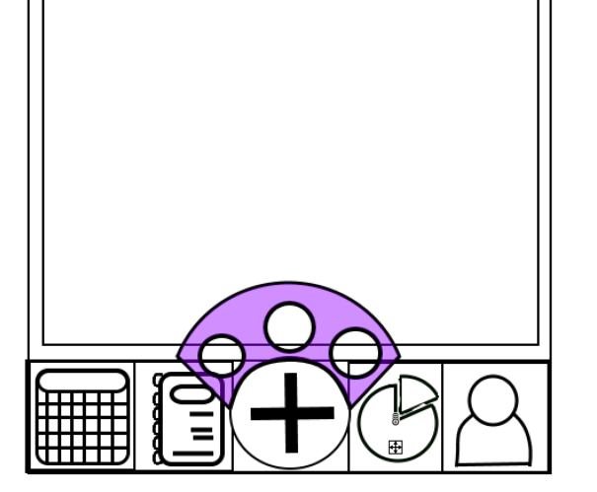

Calendar, Notes, Create event, Budget, User

For Create event, if you hold it you get another menu pop-up allowing you to pick a different type of event item: calendar(default), quick note, add on to budget spend